Athena Aplicative .exe

An easy to use program with comparative graphs.

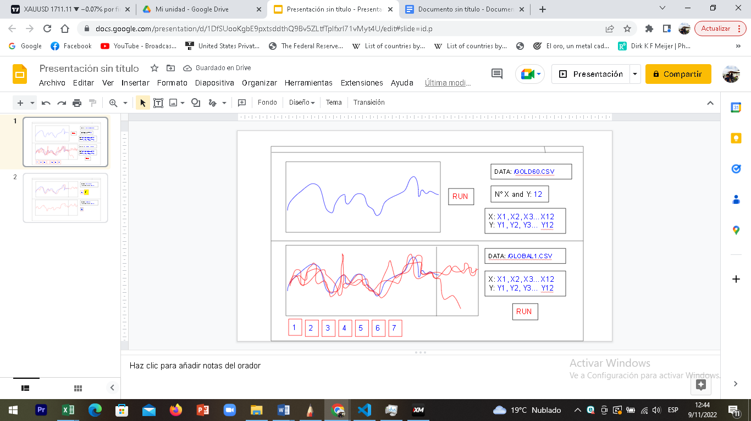

It has two divisions, The first part is runned by the following .apy

The second part is runned by the following .apy

THE FIRST PART

The purpose of the first part is to get the data of (Axis_X_arr) and (Axis_Y_arr), for this example we will only use the last 12 digits of each one, we use a simple .CSV archive, in this case GOLD60.csv.

THE SECOND PART

This part needs an special .CSV archive, in this case this o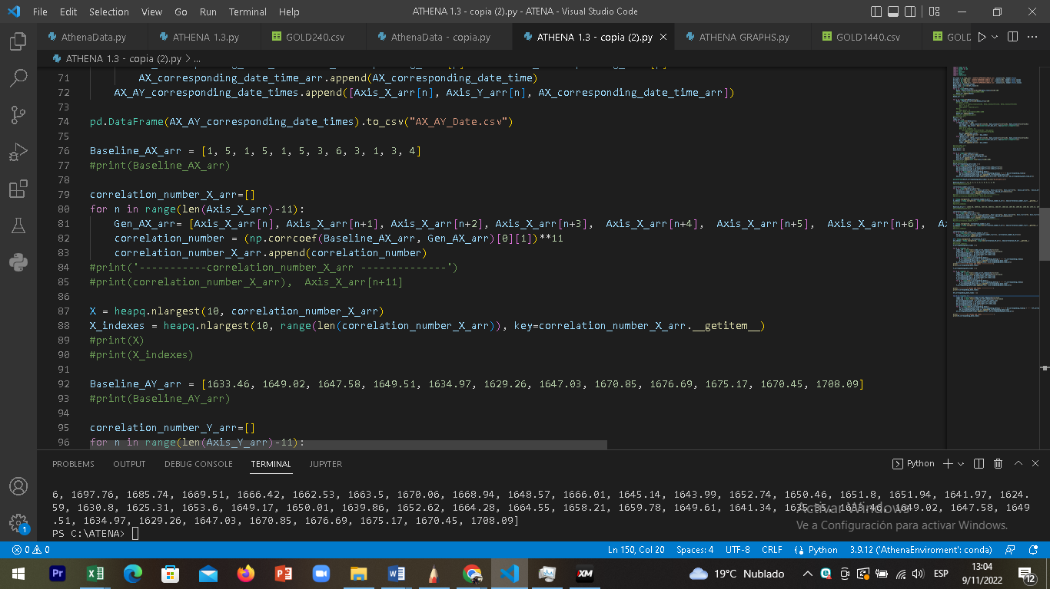ne. With the information of the last 12 digits of (Axis_X_arr) and (Axis_Y_arr)of part 1 we will run the complete .apy. The parts that must be completed are the next ones.



INSTRUCTIONS

Please follow the numbers.

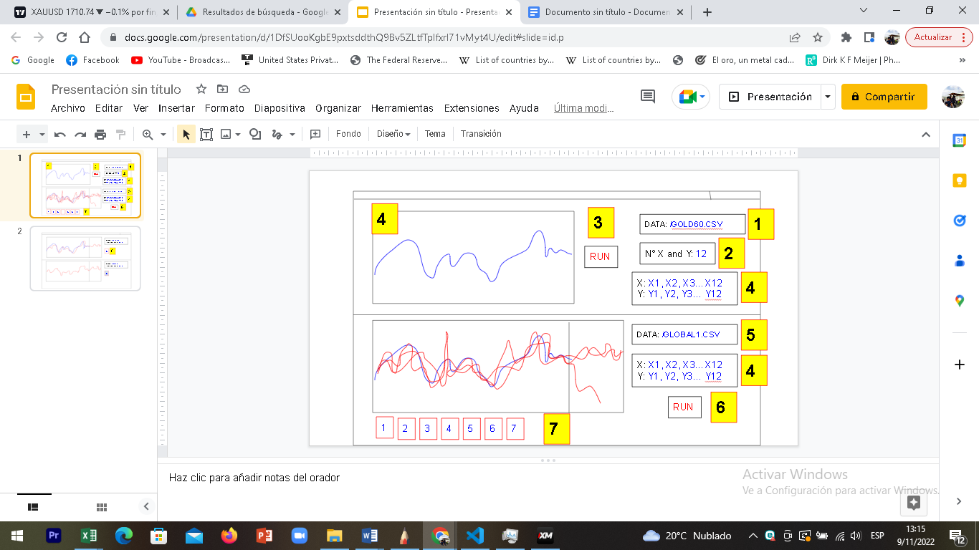

1. First the person must be able to choose any .csv according the asset analized.
2. Then he can put the number of digits that he wants to analize, 12 by default (so it will analize the last 12 digits of Array X and Y).
3. Run
4. The result must complete the corresponding graph with the last 12 digits of X and Y. The same group of numbers must be completed in the other part.
5. In the other part the person must choose the “special” .csv archive, (in this case GLOBAL1.csv)
6. Run
   1. The first graph must showed all the results of “XY Values and times” (the 7 graphs must be combined with the first graph) its important that it showed the next 20 candles of each result.



1. I should have the option to eliminate of the graph any result that I dont want with a click.

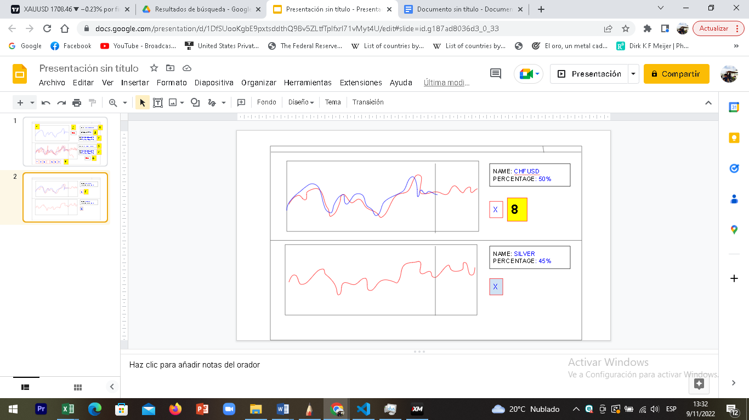

1. Then I should be able to see the (7) results with the name and percentage. The graph must be compared with the same first graph and an option to deactivate that first graph.